1. Total Revenue

select sum(total_price) as total_revenue

from pizza_sales ;



2.Average Order Value

select sum(total_price)/count(distinct order_id) as avg_order_value

from pizza_sales



3.Total Pizzas sold

select sum(quantity) as total_pizza_sold

from pizza_sales



4.Total Orders

select count(distinct order_id) as total_orders

from pizza_sales



5.Average Pizzas Per Order

select cast(sum(quantity) as decimal(10,2))/cast(count(distinct order_id) as decimal(10,2)) as avg_pizza_per_order

from pizza_sales



Daily trend for total orders

select datename(dw, order_date) as order_day , count(distinct order_id) as total_orders

from pizza_sales

group by datename(dw, order_date)

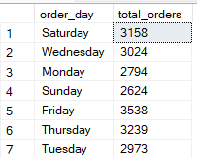

Monthly trend for total orders

select datename(month, order_date) as month_name , count(distinct order_id) as total_orders

from pizza_sales

group by datename(month, order_date)

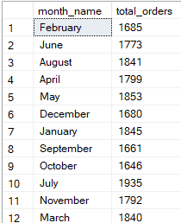

Percentage of Sales by Pizza Category

select pizza_category , sum(total_price)*100 / (select sum(total_price) from pizza_sales) as percentage_total_sales

from pizza_sales

group by pizza_category

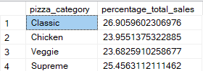

Percentage of Sales by Pizza Size

select pizza_size , sum(total_price)*100 / (select sum(total_price) from pizza_sales) as percentage_total_sales

from pizza_sales

group by pizza_size

order by percentage_total_sales

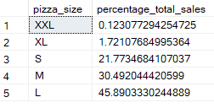

Total 5 Pizzas by Revenue

select top 5 pizza_name , sum(total_price) as total_revenue

from pizza_sales

group by pizza_name

order by total_revenue desc

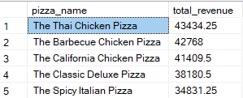

BOTTOM 5 Pizzas by Revenue

select top 5 pizza_name , sum(total_price) as total_revenue

from pizza_sales

group by pizza_name

order by total_revenue

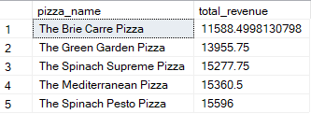

Total 5 Pizzas by Quantity

select top 5 pizza_name , sum(quantity) as total_quantity

from pizza_sales

group by pizza_name

order by total_quantity desc

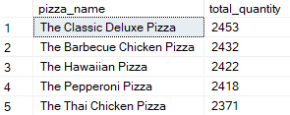

Bottom 5 Pizzas by Quantity

select top 5 pizza_name , sum(quantity) as total_quantity

from pizza_sales

group by pizza_name

order by total_quantity

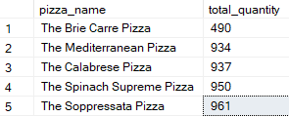

Total 5 Pizzas by Total Orders

select top 5 pizza_name ,count(distinct order_id) as total_orders

from pizza_sales

group by pizza_name

order by total_orders desc

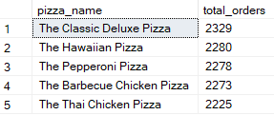

Bottom 5 Pizzas by Total Orders

select top 5 pizza_name ,count(distinct order_id) as total_orders

from pizza_sales

group by pizza_name

order by total_orders

